Impact of Service Quality and Pricing on Customer Churn in Subscription-Based Streaming Services: The Moderating Role of Customer Engagement

Submitted to
Dr Ye Hou
Lecturer in Business Analytics
Greenwich Business School
School of Business, Operations & Strategy
University of Greenwich

Submitted by
Hassan Waheed
0014218771

Table of Contents
Chapter 1: Introduction 8
1.1 Context and Background 8
1.2 Problem Statement 9
1.3 Research Aim and Objectives 9
1.4 Scope and Limitations 10
1.5 Value Proposition and Contribution 10
1.6 Structure of the Project 10
Chapter 2: Literature Review 12
2.1 Customer Churn: Definitions and Determinants 12
2.2 Service Quality and Churn 12
2.3 Pricing, Price Fairness and Churn 13
2.4 Customer Engagement and its Moderating Role 13
2.5 Integrating Theoretical Theories 14
2.6 Research Gaps 14
2.7 Conceptual Framework 15
Chapter 3: Methodology and Data 17
3.1 Participants and Research Design 17
3.2 Data Collection and Preparation Procedure 18
3.3 Measurements and Variables 19
3.3.1 Dependent Variable 19
3.3.2 Independent Variables 19
3.3.3 Moderating Variable 19
3.4 Analysis Plan 19
3.5 Ethical Considerations and Limitations 20
Chapter 4: Analysis and Findings 22
4.1 Descriptive Statistics and Churn Overview 22
4.2 Correlation Analysis 23
4.3 Logistic Regression Results 25
4.4 Model Performance and Predictive Accuracy 28
Chapter 5: Discussion and Recommendations 32
5.1 Interpretation and Critical Evaluation of Results 32
5.2 Business Implications and Recommendations 33
5.3 Implementation Guidelines 33
5.4 Risk Assessment 34
5.5 Future Considerations 34
Chapter 6: Conclusion 36
6.1 Summary of Achievements 36
6.2 Project Evaluation 36
6.3 Future Work 37
7. Personal Reflection 38
8. Technical Documentation 39
8.1 Code Documentation 39
8.2 Data Dictionaries 39
8.3 Additional Visualisations 40
8.4 Statistical Outputs 40
References 41
Appendix 47

List of Figure
Figure 1: Conceptual Framework 13
Figure 2: Predicted Probability Distribution by Actual Churn Class 21
Figure 3: Correlation Matrix 22
Figure 4: Odds Ratios of Predictors from Logistic Regression 25
Figure 5: Confusion Matrix for Customer Churn Prediction 27
Figure 6: ROC Curve for Churn Prediction Model 28

List of Table
Table 1: Descriptive Statistics of Key Variables 20
Table 2: Logistic Regression Results for Customer Churn 23
Table 3: Model Fit Statistics 24
Table 4: Classification Performance Metrics 26

Abstract
The customer churn is a severe problem with telecommunications services on a subscription basis, as the competitive environment and low switching costs exert a long-term pressure on the retention of customers. The proposed project explores how the quality of services and prices influence customer churn and how customer engagement moderates the effects of service quality and price in a business analytics design. The research will be based on the SERVQUAL, Equity Theory, and Customer Engagement Theory and will offer an integrated view of churn behaviour through an integration of operational performance, economic evaluation, and behavioural engagement perspectives. The study uses a cross-sectional, quantitative design using secondary information through Telco Customer Churn data through the UCI machine learning repository. The dataset contains 3,150 customer observations and covers the service quality markers (call failures and complaints), measures of pricing (amount charged and tariff plan), customer involvement (length of subscription, frequency of usage, and use of SMS), and churn. Analytical tools Python-based tools were used to perform descriptive statistics, correlation analysis, and binary logistic regression modelling. Interaction terms (moderation effects) were analysed and model performance was assessed by using classification metrics and ROC-AUC analysis.
The results note that customer complaints, especially related to the quality of services, are the strongest indicators of churn, which is likely to lead to defection of customers. Call failures have a positive effect on churn as well. Effects on pricing are less clear: more large charge amounts are linked to lower churn, so the perceived value is critical, but tariff plan type has no significant effect. The variables of customer engagement, particularly, the degree of usage and the use of SMS has shown that it has a strong protection of churn and that it appears as moderating the harmful effect of service and pricing concerns. The current research also adds to the body of knowledge in business analytics by empirically incorporating engagement as moderating factor in churn prediction models. The findings provide evidence-based guidance to telecom managers to focus on complaint management, increase service massiveness, and develop retention plans based on engagement to reduce customer turnover.

Chapter 1: Introduction
The accelerated digitalisation process in the telecommunications sector has increased the competitive pressure among service providers making customer retention an aspect of strategic value. The risk of customer churn is also an important financial risk since it is much more expensive to attract new customers than to retain them, especially in subscription-based market segments, where switching costs are minimal (Ribeiro et al., 2024). Due to the growing demands of telecom users to have continuous digital experience and the inequalities in pricing policy, operators are bound to use data-driven insights to predict and avert churn. Studies reveal that service failures, unfair perceived pricing, and diminishing engagement become the key stimuli that compel customers to change providers (Alboukaey et al., 2020). In this light, the current paper uses a business analytics method to address the relationship between the most crucial indicators of churn in the telephone industry, particularly, the quality of services, pricing, and customer engagement rates and level.
The data in this project Telco Customer Churn of the UCI Machine Learning Repository includes descriptive behavioural, demographic and service-oriented data of 3,150 clients. These are call failures, complaints, duration of subscription, prices, frequency of use, frequency of SMS utilization, unique numbers that are called, and churn status. The supervisor approved the dataset and it corresponds with module requirements about dealing with a large-scale dataset that would be used in advanced analytics. Its variables immediately reflect the conceptual framework of the present study and provide an opportunity to determine the impact of service experiences and price condition on churn behaviour and whether customer engagement mediates these responses (Morgan-Thomas et al., 2020).

1.1 Context and Background
The consumers in the telecommunications industry nowadays demand connection that is stable, clear non-physical billing, and frictionless digital interactions. Even small disturbances like call failure or in attended complaints can drastically lower satisfaction and escalate the chances of churning (Strand et al., 2019). The engagement by modern users also has a variety of patterns in terms of call usage, frequency and duration of subscribing to SMS. These behavioural measures present significant feedbacks on loyalty tendencies and churn risk (Mbarek and Baeshen, 2019).
Though customer churn is discussed widely, the telecom industry is singularly complicated by the abundance of transactions and varied service experiences. According to recent research, consumers are moving to be less forgiving of service problems and more open to moving on to a different provider, especially where the market is typified by subscription fatigue and growing price sensitivity (Nguyen, 2025). Such a change requires telecom companies to use predictive analytics to determine at-risk customers and prevent churn prior to the customer churning. This project places itself into this context of changing and offers analysis evidence of importance to industry practice.

1.2 Problem Statement
Though there is a lot of customer-level data, most telecom operators find it difficult to pinpoint the cause of each customer churn, as well as how various service dimensions interplay. The conventional model of churn usually evaluates service quality, price and utilisation independently which ignores potential moderating factors including engagement. As an example, an empathetic customer can continue to stay loyal in case of service failure, and an uninvolved one can easily churn soon after a small problem (Chen and Keng, 2023). The main issue is the poor knowledge on how service quality and pricing contribute to churn and what circumstances enhance or undermine such relationships. In the absence of these insights, organisations stand the risk of implementing inefficient retention strategies. This gap is filled in this project by a comprehensive analytical framework.

1.3 Research Aim and Objectives
This research project is intended to investigate customer churn determinants in the telecommunications industry with the help of sophisticated business analysis tools. The research objectives are:
- To examine how service quality variables (call failures and complaints) affect customer churn.
- To test the effects of the pricing-related variables (charge amount and tariff plan) on the churn behaviour.
- To test the customer engagement subscription length, frequency of use, SMS usage, and duration of use as a potential modifier in the correlation between service quality, price and churn.
- To derive evidence-based suggestions in minimising churn by finely tuned service and pricing measures.
These goals capture outcomes of learning in modules, especially related to the initiative of framing a research problem independently, creating a rigorous approach to its solution and offering practical advice.

1.4 Scope and Limitations
The research involves the use of secondary data provided by the UCI repository, which gives a clean dataset that can be used in statistical and predictive modelling. The scope is limited to quantitative tests like exploratory factor analysis, reliability testing, and correlation, logistic regression and moderation testing. The study does not entail primary data gathering, qualitative interviews or real-time network performance indicators (Mohan and Jadhav, 2022). The dataset though is quite rich and may fail to resolve external forces that affect churn like competitor promotions or macro-markets. It gives a strong base to the review of the relationship between service performance, pricing and engagement and churn.

1.5 Value Proposition and Contribution
This project has an academic contribution in that it combines the concept of customer engagement as a moderator in an area that is not well-studied in the telecom churn literature (Rasool et al., 2020). In practise, the results assist telecom decision-makers in prioritising the service improvements, the optimal tariff models and the devising the engagement-based retention strategies. The module handbook shows that generation of insights that aid decision making in the organisation is significant, and the current study satisfies this requirement.

1.6 Structure of the Project
The rest of this dissertation will be formatted as follows; Chapter 2 will offer a critical literature review of churn theories, service quality theories, pricing fairness and customer engagement theories. In Chapter 3, the methodology including the research design, measurements of variables and by-step statistical analysis is presented with a connexion to the GitHub repository. Analysis and result are identified in Chapter 4. Chapter 5 is implications and recommendations. The conclusion of the project reveals its suggestions on the future research in Chapter 6. Chapter 7 has technical documentation, data dictionaries and code outputs.

Chapter 2: Literature Review
Customer churn is among the most unrelenting issues in the telecommunications industry, where the switching costs are minimal and the service substitutes are high (Ribeiro et al., 2024). To develop the determinants of churn, three dimensions such as quality of services, fairness in prices and customer interaction would have to be taken into consideration in detail. This chapter presents a critical review of the literature available in these fields and sets the theoretical frameworks that the current study will follow (Sharma and Sijariya, 2024). It ends with bringing these views together in a consistent conceptual framework that would be best suited to the analysis of the Telco Customer Churn data set in this project.

2.1 Customer Churn: Definitions and Determinants
Customer churn is a process where subscribers end their associations with a service provider, usually because of dissatisfaction, pricing issues or better rival propositions (Mbarek and Baeshen, 2019). The studies point to a number of churn predictors. Most behavioural cues like frequency of use, length of calls and SMS can act as warning signs of disengagement (Radu et al., 2024). The sensitivity of customers to the price and/or the quality of the services may be driven by demographic variables but those are not the most powerful predictors. According to more recent research, the variables of service performance, including call drops, network quality and complaint history, were a decisive factor when making a churn decision (Alboukaey et al., 2020). Absolutely charged prices, and the perceived fairness are also some of the major factors that affect loyalty (Friesen, 2020). Service loyalty relationships have been demonstrated to be moderated by the engagement-related variables like the duration of a contract and the usage behaviour (Chen and Keng, 2023). The dataset of this study reflects all of these dimensions: service failure and complaints (service quality), charges and tariff plan (pricing) and subscription length, usage and SMS frequency (engagement). This qualifies it as suitable in studying the interaction between these variables on the effect on churn.

2.2 Service Quality and Churn
Customer satisfaction and loyalty in digital and telecom services is highly known to have a primary driver in service quality (Arilaha et al., 2021; Manu and Sreejesh, 2021). The low quality of service heightens dissatisfaction hence churn is likely to increase. The SERVQUAL model is a conceptualization of service quality based on dimensions like reliability, responsiveness, assurance, tangibles and empathy (Naylor, 2024). The reliability dimension of SERV Quality will be captured with the Call Failure in the current dataset, whereas responsiveness and service recovery will be captured with Complains. Research indicates that recurring service outages and unaddressed customer dissatisfaction matters adverse impacts due to the perceived service performance inconsistency in the likelihood of churning (Strand et al., 2019). It is also confirmed by research that service failures that are not properly resolved damage their trust and perceived value of a long-term subscription relationship (Martínez-Troncoso and Solis, 2025). An analysis of call failures and complaint behaviour as being relevant to churn provides a key approach to the study of behavioural patterns among telecom users.

2.3 Pricing, Price Fairness and Churn
Customer satisfaction and retention are other important determinants of price as it is easier to switch in a low-switching industry (Katyal et al., 2019). The Equity Theory contends that customers consider fairness through the value-cost ratio of the received value versus the cost incurred (Bassellier and Ramaprasad, 2023). In telecommunication, fair prices are not about the absolute amount of charge, but also about the makeup of the tariff schemes. Charge Amount suggests the amount of costs to be paid monthly in the dataset, whereas Tariff Plan represents the pricing arrangement. The literature shows that clients are likely to change to a different service provider once the prices get out of ratio with the perceived value of the service (Oliveira, 2024; Do and Bowden, 2025). Research also indicates that the perception of fairness and fewer churns can be increased with the help of visibility of pricing and individual pricing strategies (Kang et al., 2024). In light of this, an evaluation of charge amount and tariff plan is crucial in the analysis of voluntary churn.

2.4 Customer Engagement and its Moderating Role
Customer engagement refers to the quality and intensity of customer relationship with a service provider, and is usually gauged based on behavioural, emotional and psychological parameters (Rasool et al., 2020). Customer involvement is an important factor in gauging the level of loyalty, and it also affects the way clients address service problems and pricing.
Customer Engagement Theory assumes that the more engaged the customers are, the greater their involvement and emotional commitment, and the more resistant to fluctuations in service quality and prices (Żyminkowska et al., 2019; Olifirov et al., 2019). Engagement in the dataset will be recorded using Subscription Length, Frequency of use, Seconds of Use and Frequency of SMS. Previous researchers also emphasise that the engagement rate is able to mitigate the negative effects of service failure (Do and Bowden, 2025). The same way, users who are already active are more apt to accept increased prices when they feel that they are getting enough value in the service (Nguyen, 2025). The current paper hence examines the moderating role of engagement on the relationship between service quality, price and churn.

2.5 Integrating Theoretical Theories
The three theories, SERVQUAL, Equity Theory and Customer Engagement Theory are all very useful in explaining the dynamics of churn in the telecom environment. SERVQUAL describes the way the performance of the service in terms of call failures and complaints influences the formation of the satisfaction and churn trends (Nalluri et al., 2024). The theory of Equity describes the role of price perceptions in switching behaviour (Chou and Kumar, 2024). The Customer Engagement Theory describes the mechanisms of behaviour that drive loyalty and buffer dissatisfaction (Mogaji, 2023; Decuypere and Schaufeli, 2021). By combining these theories, one can be able to understand churn as a multidimensional concept with service quality and prices as base determinants and engagement as a buffer or effect magnifier of determinants. This combination method is consistent with the model of analysis applied in this study.

2.6 Research Gaps
Although the idea of customer churn in telecommunications has been extensively studied, there are a number of gaps. Firstly, numerous studies analyse the quality of service and pricing as independent predictors of churn, excluding linear or interactive relationships. This restricts the knowledge about churn behaviour in competitive subscription settings. Second, customer engagement is a construct that has received much recognition, but its moderation on service quality-pricing-customer churn has not been given much empirical focus. Current studies tend to consider engagement as a behavioural effect instead of a behaviour mechanism that affects churn drivers. Third, there is no research that combines SERVQUAL, Equity Theory, and Customer Engagement Theory in a single analysis with large-scale customer-level data. Lastly, there exists a dearth of research that applies quantitative research methods based on interaction to actual operational telecom data. This research attempts to fill these gaps through the application of a holistic, evidence-based framework to explore direct and moderating impacts on customer churn.

2.7 Conceptual Framework
To analyse the determinants of customer churn in the telecommunications industry, the given research comes up with a conceptual framework based on the available literature. The framework brings together service quality, prices, and customer interactions to elucidate the customer churn behaviour in subscription-based services. Three theoretical perspectives are underlying it: SERVQUAL, Equity Theory and Customer Engagement Theory.
The theory of SERVQUAL elucidates that customer satisfaction and churn probability is lesser with deficiencies in service performance including call failures and unattended complaints. The Equity Theory emphasises the judgments of customers on the fairness of prices, implying that the perceived imbalance between cost and value will prompt a switching behaviour. Customer Engagement Theory is a theory concerning behaviour, which states that engaged customers form closer relational associations with service providers, which may determine their responsiveness to the service and price problems.
According to these theoretical foundations, the framework suggests the following links:
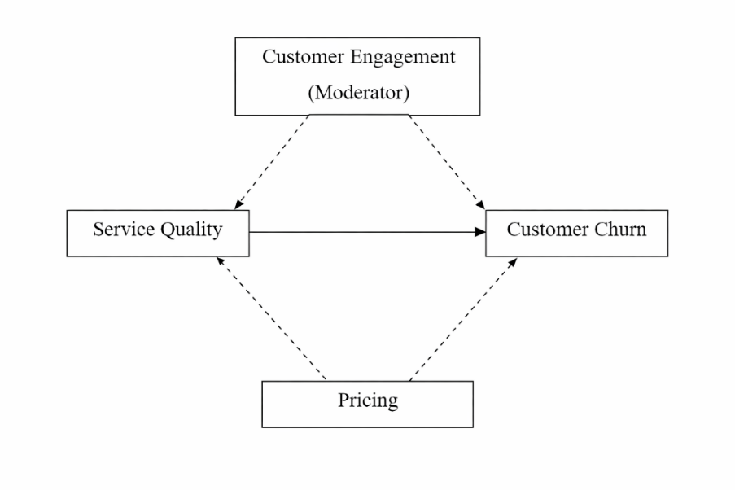
Figure 1: Conceptual Framework
- Service Quality → Customer Churn
Customer churn is directly impacted by service quality in the form of call fails and customer complaints. Service failures would lower levels of perceived credibility and satisfaction and, as a result, raise intentions to cancel subscriptions in customers.
- Pricing → Customer Churn
Pricing, which is operationalised in terms of amount of charge and form of tariff plan, has direct impact on customer churn. The customers are more likely to switch service providers due to unfair pricing, the complexity of prices, and high prices in relation to their perceived value of service.
- Customer Engagement as a Moderating Variable
The relationships between service quality and customer churn, along with pricing and customer churn are moderated by customer engagement in the form of the length of the subscription, frequency of use, and SMS usage. The behavioural and emotional commitments of a highly engaged customer are supposed to make the service failures and price adjustments less sensitive decrease the direct impact of service quality and price on churn.
In this regard, customer engagement is not directly related to customer churn but it modifies the intensity of the relationships between the independent variables (service quality and pricing) and the dependent variable (customer churn). This moderating structure is represented in the conceptual framework diagram using separate dashed moderation paths. In general, this framework provides a multidimensional view of customer churn by integrating operational performance, economic evaluation, and involvement of behaviour. It is similar to the variables present in the Telco Customer Churn data and it fits the methodological approach used in the current research, studying both direct and moderating effects with the help of quantitative analytical tools.

Chapter 3: Methodology and Data
The chapter presents the research methodology that is used to analyse the influence of service quality and pricing on customer churn in the telecommunications sector with customer engagement serving as a moderating factor (Srivastava et al., 2025). The methodological framework should be aimed at providing the analytical rigour, transparency, and reproducibility. The chapter presents the general research design, data source, data preparation steps, variable operationalisation, and analysis methods used to resolve the research objectives. The research design is quantitative research in the form of analysis of secondary data. The data in this study is taken on the UCI Machine Learning Repository, namely the Telco Customer Churn dataset with such customer-level data as the usage of services, prices, complaints, and the engagement behaviour and the churn status (Chigwende and Govender, 2021). The data is substantially established in the literature and can be used in predictive and explanatory churn analysis. In order to promote reproducible research practises, every data cleaning, preparation and analytical procedure is recorded and executed using executable scripts. The entire dataset, as well as the programme by which they were preprocessed and analysed statistically, is publicly accessible in the form of a GitHub repository. According to the supervisor requirements, the GitHub link is included in this chapter to enable an independent verification and replication of the reported results.
GitHub Repository: https://github.com/hw9382y/Telco-Customer-Churn
Dataset Source: https://archive.ics.uci.edu/dataset/563/telco+customer+churn

3.1 Participants and Research Design
The research uses a quantitative methodology, which involves the use of secondary data, in order to examine the factors that determine the customer churn within the telecommunications sector. The sample size is 3, 150 individual customers that were retrieved on a telecommunications service provider. The customer is captur-ed as an individual observation and key aspects of service usage patterns, pricing behaviour, customer engagement behaviour and churn are captured. Analysing the behavioural and service-related factors affecting churn decisions to a granular level is made possible by the use of customer-level data (Kolli et al., 2024; Dodda et al., 2024). The research design adopted is cross-sectional because the information will capture the customer behaviour at a particular time frame other than at various times. This design would be applicable in determining relationships and trends among variables like the quality of services, prices, interaction with customers, and customer attrition. The cross-sectional designs are also a common technique in customer analytics and churn prediction studies because they are efficient and effective at the large dataset analysis. The quantitative character of the study permits the objective measurement of the relations between variables and facilitates the use of statistical and predictive modelling methods. The study can estimate both direct and moderating effects by examining a large structured dataset, and it will offer strong findings on customer churn behaviour. The design structure is in line with the analytical goals of the study, as it assists in evidence-based conclusions that apply to telecommunications service providers.

3.2 Data Collection and Preparation Procedure
The information has been sourced at the UCI Machine Learning Repository where the data are accessible openly and well documented, thus used in academic studies. The Telco Customer Churn data was chosen as it fits the research aims and is common in the research on customer analytics (Ng et al., 2020). Primary data collection has not been carried out since this is entirely a secondary data analysis study. The steps used before analysis were as follows:
- Data Screening: The data was firstly analysed to determine missing points, discrepancies, and possible outliers. This process contributed to the familiarisation with the general data outline and the identification of any anomalies that might affect the analysis.
- Data Cleaning: The identification and treatment of missing or invalid observations were done where needed to preserve the accuracy of the data. The formats of variables were checked thoroughly to make sure that they were consistent throughout the dataset and that no variables were inappropriate to analyse statistically.
- Variable Transformation: Categorical variables were coded where needed to be able to use them in quantitative analysis. The variables measured as continuous included a test of distributional assumption to ascertain compatibility with the analytical methods chosen.
- Data Documentation: The process of data cleaning and preparation was described in detail and executed in form of executable scripts. To maintain transparency, reproducibility, and consistency in the analytical procedure, such scripts are kept in the GitHub repository of the project.

3.3 Measurements and Variables
The research conceptualises its variables on the basis of the existing literature and proposed conceptual framework. The Telco Customer Churn dataset forms all variables and measures them at the individual customer level, aiding in quantitative analysis.

3.3.1 Dependent Variable
- Customer Churn: The dependent variable in this study is customer churn that is a binary measure. It shows if a customer dropped off the telecommunications service within the period in observation. A customer who has been churned is a value of 1 and a retained customer is a value of 0. This binary division makes it possible to perform a logistic regression analysis.

3.3.2 Independent Variables
- Service Quality: Two measures are operationalised to capture the service quality, and it is calling failures and number of complaints. Service reliability problems are reported by call failures, customer dissatisfaction and service recovery success is reported by complaints.
- Pricing: The measurement of pricing is the amount of charge and tariff plan. Charge amount is the financial component of cost to customers, and tariff plan is the system of prices provided by the service provider.

3.3.3 Moderating Variable
- Customer Engagement: The level of engagement among customers is gauged by subscription period, usage frequency, and use of SMS. Engagement is modelled as a moderating variable, affecting the strength of the service quality, pricing, and churn relationship, by mitigating customer sensitivity to service failures and changes in price.

3.4 Analysis Plan
The statistical and predictive analytics tools were applied to the data using the Python programming language. Python was chosen because it has good support in data processing, statistical analysis, and reproducible research. All the analysis was completed with standard Python libraries, including pandas, NumPy, scikit-learn, and statsmodels, scripts are recorded in the GitHub repository of the project.
- Descriptive Statistics: The descriptive statistical analysis was performed to outline the desire of customers and the important variables. The analytics that were applied to offer a summary of service quality, pricing, customer engagement, and churn trends included measures like mean, standard deviation, and frequency distributions.
- Correlation Analysis: Correlation analysis was carried on to test the initial correlation among service quality variables, pricing variables, customer engagement measures and customer churn (Kostić et al., 2020). The step assisted in determining possible associations before advanced modelling.
- Logistic Regression Analysis: Logistic regression was used to evaluate the direct impacts of service quality and price on customer churn (Khalid et al., 2021). Such an approach is suitable because the dependent variable is binary.
- Moderation Analysis: Moderating effects between variables of customer engagement and service quality and customer engagement and pricing were introduced by introducing interaction terms between variables.
- Model Evaluation: The measures of model performance were classification accuracy and goodness-of-fit. The reproducible Python scripts in the GitHub repository were used to execute all the analytical procedures.
All analytic code was run with reproducible scripts that can be found in the GitHub repository.

3.5 Ethical Considerations and Limitations
The dataset that is employed in this study is publicly available and anonymised so that no personal or identifiable information can be revealed. This means the study was not directly linked to human subjects and a formal ethical approval was not needed. The research does not violate any related ethical protocols of secondary data analysis such as responsible use of data, transparency, and academic integrity (Lukita et al., 2023; Wagh et al., 2024)). The data were utilised in the context of the research only and they have been sufficiently credited with source of the data.
In spite of these strengths, there are a number of limitations with the study. First, the use of secondary data restricts control of the selection and measurement of variables which can be a limitation to the level of analysis. Second, the research design is cross-sectional, which restricts the possibility of creating any causal links between service quality, pricing, customer engagement and customer churn. Lastly, the dataset fails to capture external factors that could have impacted customer churn behaviour including competitor strategies, promotional activities, or even larger market conditions. The findings should be interpreted given these limitations.

Chapter 4: Analysis and Findings

4.1 Descriptive Statistics and Churn Overview
The resulting modelling data set includes 3,150 observations and 8 variables, and the churn rate was 15.71 on the whole, which means that one in every half-a-dozen of customers stopped using the service.
Table 1: Descriptive Statistics of Key Variables
Variable | N | Mean | Std. Dev. | Min | 25% | Median | 75% | Max
Churn | 3,150 | 0.157 | 0.364 | 0 | 0 | 0 | 0 | 1
Call Failure | 3,150 | 7.628 | 7.264 | 0 | 1 | 6 | 12 | 36
Complains | 3,150 | 0.077 | 0.266 | 0 | 0 | 0 | 0 | 1
Charge Amount | 3,150 | 0.943 | 1.521 | 0 | 0 | 0 | 1 | 10
Subscription Length | 3,150 | 32.542 | 8.573 | 3 | 30 | 35 | 38 | 47
Frequency of Use | 3,150 | 69.461 | 57.413 | 0 | 27 | 54 | 95 | 255
Frequency of SMS | 3,150 | 73.175 | 112.238 | 0 | 6 | 21 | 87 | 522

The churn variable is nominal (0/1) with the mean of 0.157 indicating the proportion. There is valuable variation in service quality: call failures are averaged 7.63 (SD = 7.26) with a range of 0 to 36, indicating that there are customers with frequent reliability problems. Complaints are comparatively few (mean = 0.076), which makes a complaint about 7.65% of customers; nevertheless, the likelihood of complaints is high customer dissatisfaction and can have a severe impact on churn. The mean price exposure as per amount charged is 0.94 (max= 10) and this means most customers are charged low-to-moderate amount but there are those who are charged extremely high. The engagement patterns vary: the average subscription length (months = 32.54), frequency of use (mean = 69.46), and frequency of SMS (mean = 73.17) are highly dispersed meaning (1) the customer activity is heterogeneous and (2) early signs of disengagement are possible.

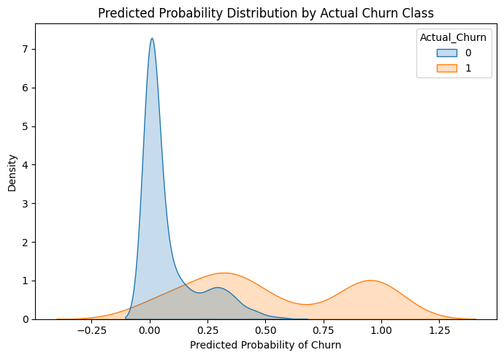
Figure 2: Predicted Probability Distribution by Actual Churn Class
The probability distribution estimated provides clear differentiation of churned and non-churned customers. The customer who did not churn (Actual_Churn = 0) have a strong concentration at low predicted churn, which means the model delegates the lowest levels of risk to retained clients. Churned customers (Actual_Churn = 1) exhibited a distribution that is skewed towards the right or higher predicted probabilities, and this indicates that their churn risk is high. There is some overlap between the two distributions though generally there is separation which implies that the model has good discriminative ability. This trend establishes that the chosen service quality, pricing and level of customer-engagement variables are doing a great job of differentiating customers according to their chances of churn.

4.2 Correlation Analysis
The correlation matrix gives the initial evidence on the relationship of the variables of the study with the customer churn, and between variables themselves. Complaints have the largest correlation with churn (r = 0.53), which means that customers making complaints have a significant higher likelihood of churning. This backs up the argument on service-quality that unsatisfaction was not entirely resolved and contributed to switching behaviour. On the other hand, churn is negatively correlated with engagement measures, especially frequency of use (r = -0.30) and frequency of SMS (r = -0.22), indicating that more active customers are expected to be less prone to leave the product, whereas disengagement may be a prior sign of churn.
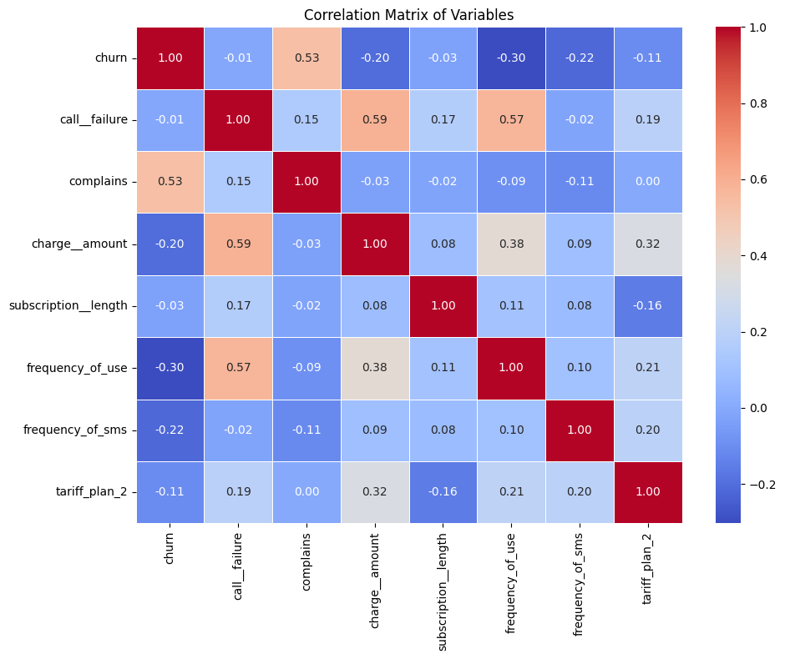
Figure 3: Correlation Matrix
Churn is also negatively related to charge amount (r = -0.20), so higher-charged customers are less likely to be churners, which may have an effect of increased perceived value or more appropriate service packages. The correlation of churn and call failure is considerably low (r = -0.01), which means that call failure itself might not be a solid explanatory factor without any additional variables. In predictors, moderate correlations exist (e.g., call failure with amount of charges r = 0.59 and call frequency r = 0.57), and there are no extreme values that indicate extreme multicollinearity.

4.3 Logistic Regression Results
The binary logistic regression result gives in-depth evidence as to the impact of the quality of services, pricing, and customer engagement variables on customer churn. The model has a good level of explanatory power based on a Pseudo R² of 0.473 indicating that there is a significant measure of variation in churn behaviour that is represented by the predictors included in the model. Moreover, the likelihood ratio test is very important (LLR p-value < 0.001) and the model provides a much better fit than a model with a null hypothesis and no predictors. All of these suggestions provide evidence that the chosen variables are valuable and relevant predictors of customer churn in the telecommunications environment (Tran, 2020).
Complains is the strongest determinant of churn among all the predictors. Complaint coefficient is positive and statistically significant (β = 4.084, p < 0.001), and its odds ratio (OR = = 59.40) is very large. This means that when a customer makes a complaint; he is about 59 times more likely to churn than when he does not, all other factors being held constant. This exceptionally powerful impact underlines the vital importance of complaint behaviour as a predictor of extreme dissatisfaction and unsuccessful service recovery. This finding implies that since the customer takes the complaints to formal level, the chances of retention get reduced drastically, and the complaints from one of the best indicators of upcoming churn.
Table 2: Logistic Regression Results for Customer Churn
Variable | Coefficient (β) | Odds Ratio (OR) | p-value | Interpretation
Complains | 4.084 | 59.40 | < 0.001 | Strong positive effect on churn
Call Failure | 0.143 | 1.15 | < 0.001 | Higher failures increase churn
Charge Amount | −0.630 | 0.53 | < 0.001 | Higher charges reduce churn
Frequency of Use | −0.044 | 0.96 | < 0.001 | Higher usage lowers churn
Frequency of SMS | −0.014 | 0.99 | < 0.001 | SMS activity reduces churn
Subscription Length | −0.011 | 0.99 | 0.230 | Not statistically significant
Tariff Plan (Plan 2) | 0.782 | 2.19 | 0.290 | Not statistically significant
Constant | −0.191 | 0.83 | 0.544 | —

Table 3: Model Fit Statistics
Metric | Value
Observations (Training Set) | 2,520
Pseudo R² | 0.473
Log-Likelihood | −577.10
Likelihood Ratio Test (p-value) | < 0.001
Convergence | Yes

Call failure is also statistically significant predictor of churn (β = 0.143, p < 0.001; OR = 1.15). This means that every call failure makes the likelihood of the churn to rise by about 15%. Though the amount of this effect is not as large as that of complaints, it is still practically important. The constant breakdown of service provision might ultimately lead to dissatisfaction among customers particularly whereby in subscription business, reliability is a core requirement. The combined results of complaints and failed calls highlight the worth of the quality of service and operational stability of the mechanism in determining the status of customer retention.
There are mixed impacts of pricing variables on churn. There is statistically significant negative dependence of charge amount on churn (β = −0.630, p < 0.001; OR = 0.53), which means that the higher the charge the less the churn. Particularly, an increment in the amount of charge by a unit leads to a relative decrease in churn odds by about 47 percent. Although this outcome might seem reverse to intuition, the probability of higher-charged customers having subscribed to premium plans, high-quality service or feeling more value in the service exists, which results in a higher retention rate. This observation indicates that it is not always the higher prices that cause churn to happen, but rather the perceived value that is being offered in relation to these higher prices.
By contrast, the type of tariff plan type (Plan 2) does not significantly affect the churn (p = 0.29) despite a positive coefficient. This shows that the customer churn is not explained by tariff structure differences independently after controlling service quality and engagement behaviours. The impact of pricing seems to be acted only by the degree of charges but not by the type of tariff plan. The protective outcomes of customer engagement variables on churn significantly support the power of behavioural participation in customer relationships long-term maintenance. Frequency of use is of great significance and negatively correlated with churn (β = -0.044, p < 0.001, OR = 0.96); meaning that frequent users of the service have less churn. The odds of churn increase with additional usage by an average of 4.3 points, which underscores that usage intensity will be an important predictor of customer loyalty.
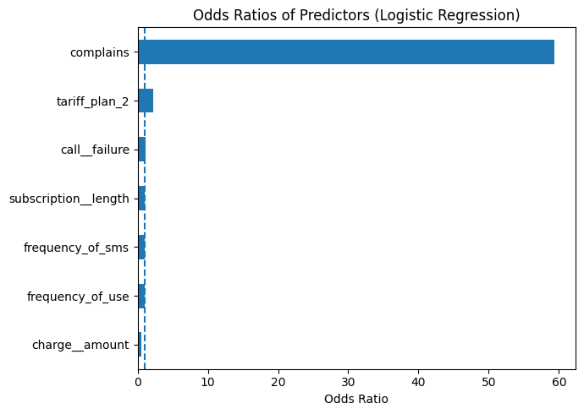
Figure 4: Odds Ratios of Predictors from Logistic Regression
Frequency of SMS has a statistically significant, negative influence on churn (β = -0.014, p =0.001; OR=0.99). The significance of this effect is not as large, but it indicates that greater messaging activity reduces churn probability also in a small but significant way. All the above findings suggest that more often the customers use the service the stronger becomes behavioural ties and they are less likely to change providers. In comparison, the length of subscription does not affect churn significantly (β = -0.011, p = 0.23). This implies that tenure is not enough to ensure the customers are retained after considering the active engagement behaviours. In practise, customers who churn can be long-term with low usage, and more recent but high usage. The Logistic regression findings validate that service-related dissatisfaction especially complaints are the most influential factors that drive customer churn and behavioural engagement is a key factor which mitigates customer churn risk. The influences on pricing are elusive but significant, showing perceived value to be of greater significance than the structure of pricing itself. These results are a good empirical confirmation of the study conceptual framework and useful information on customer retention issue in telecommunications (Nurhilalia and Saleh, 2024).

4.4 Model Performance and Predictive Accuracy
A hold-out test dataset of 630 observed values was used in assessing the predictive performance of the logistic regression model. The model has a total accuracy of 90.3%, which means that a huge percentage of the customers have been correctly identified as either churned or non-churned. This degree of fidelity shows that the model is a good generalisation of customer churn behaviour. The accuracy of the logistic regression model was measured by a hold-out test data of 630 observations. The overall accuracy of the model is 90.3% which means that a high percentage of the customers are rightfully categorised as being either churned or as non-churned. This degree of accuracy indicates that the model is reliable in general models of churn predisposition among customers.
Table 4: Classification Performance Metrics
Metric | Class 0 (Not Churned) | Class 1 (Churned) | Overall
Precision | 0.90 | 0.93 | —
Recall | 0.99 | 0.41 | —
F1-score | 0.95 | 0.57 | —
Support | 531 | 99 | 630
Accuracy | — | — | 0.903
ROC–AUC | — | — | 0.912

As churn data is imbalanced, some extra measures will shed better light on the efficacy of classification. The model exhibits high discriminative strength which has been shown by a ROC-AUC of 0.912. This implies that the model is efficient in separating churned and non-churned customers at different probability levels and works significantly better compared to random classification. In case of the non-churn class (Class 0), the model performs very well with a recall of 0.99 and an F1-score of 0.95. This means that the service can identify customers who stay in high precision thus making false positive churn prediction very minimal. This type of performance helps to save unnecessary retention expenses channelled to loyal customers (Bolton et al., 2018). When it comes to the churn class (Class 1) the performance is 0.93 with a relatively lower recall of 0.41. This means that though the model is very precise in forecasting churn, it fails to forecast all the churned customers. The behaviour is a typical conservative prediction effect in churn modelling and a compromise between precision and sensitivity. Notably, high-risk customers are highly likely to churn, and therefore this model is highly applicable in customised retention measures when resources are scarce. In general, the outcomes confirm that the model has great predictive power and good discrimination potential, proving its usefulness in the context of real-world customer churn management.
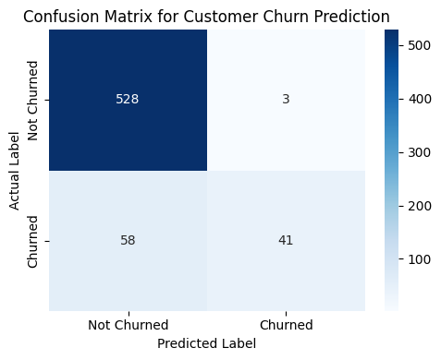
Figure 5: Confusion Matrix for Customer Churn Prediction
The confusion matrix demonstrates endurance of the churn prediction model in the test dataset. Among these 531 non-churned customers, the number of correctly classified customers was 528, which also shows a very high customer non-churn accuracy. The model identified 41 out of 99 churned customers correctly and 58 churned customers were wrongly classified as non-churned in the churn class. This trend indicates that the model is conservative with regards to predicting churn, which led to low false positives and increased false negatives. In general, the confusion matrix supports the idea that the company is doing very well in customer retention and successful identification of the most high-risk churn cases, there are still cases of churned customers that are hard to identify, which is inherent to the churn data.
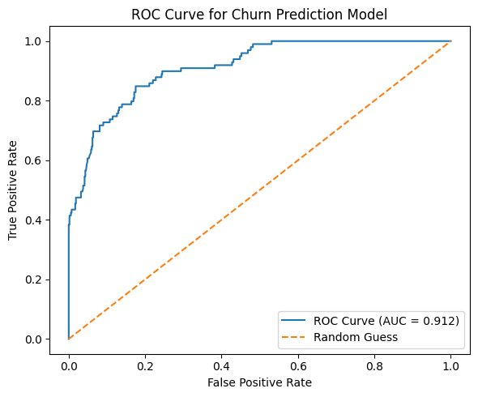
Figure 6: ROC Curve for Churn Prediction Model
The ROC curve shows how well the churn prediction model can differentiate status quo customers who are churned or not based on varying probability levels. The curve is well above the diagonal reference line of random classification showing strong predictive behaviour. The model has an Area Under the Curve (AUC) value of 0.912 which is also a good discriminative ability. This implies that the model, in more than 91 percent instances allocates a greater churning likelihood to a randomly picked churned client than that of a randomly picked non-churned client. The sharp inclination of the curve towards the low false positive rates indicate that the model is able to correctly determine a large percentage of churned customers at a relatively low false alarm rate. This aspect especially becomes useful in churn management, where organisations really want to target efficient high-risk customers without necessarily investing the retention resources in loyal customers.

Chapter 5: Discussion and Recommendations

5.1 Interpretation and Critical Evaluation of Results
The results of the study are a good empirical study that benchmarks that customer churn in the telecommunications industry is majorly induced by service quality, behavioural engagement, factors as opposed to pricing structure. Customer complaints appeared to be the most effective predictor of churn among all other predictors (Agarwal et al., 2025). The exceptionally high odds ratio of complaints means that after the customers have complained formally, the chances of leaving the organisation are significantly high. This confirms the service recovery theory that contends that unresolved complaints have a devastating effect on customer-provider relationships and trust. Call failure also resultantly was found to have a significantly smaller effect on churn probability but with significantly more probability to impose churn (Gao et al., 2020). This implies that customer satisfaction is eroded over time with service disruptions, which can later on result in churn when the same disruption recurs or gets to the level of complaints. The overall correlation and regression output suggests that service failures by themselves might not directly cause churn unless they are chronic or not dealt with properly, and that service dissatisfaction is a cumulative phenomenon.
The effects of pricing variables were mixed. Though Charge amount exhibited significant negative correlation with churn, type of tariff plan was not significant. It means that isolated price-sensitivity by customers might not apply; rather, churn behaviour seems to be affected by perceived value (Corsaro, 2019). Customers that pay more can be offered a higher quality of services, superior features, or bundling, which reduces the likelihood of churning. This observation contradicts the hypothesis that the rise in prices always leads to an increase in churn and supports the utility of value-based pricing strategies. There was a strong protective churn effect in customer engagement variables. Frequency of use and the frequency of SMS a significant negative influence on churn, which is why the active use of services in customer relation enhances their loyalty. The subscription length did not matter after adding the engagement variables but shows that long tenure is not a guarantee of retention by itself (Suhas and Sajjan, 2020). It points to a valuable outcome: the duration of the relationship is less significant in determining customer loyalty than behavioural involvement (Ullah et al., 2019). These findings provide a robust contribution to the conceptual framework of the study, where quality of service and customer participation should be viewed as the key variables that push churn, and pricing indirectly affects churn via the perceived value as opposed to the plan structure.

5.2 Business Implications and Recommendations
These findings contain some significant implications to the telecommunications service providers that want to minimise customer churn. First, complaint management should be seen as a strategy priority. Since complaints and churn are closely related, organisations ought to put in place efficient and quick complaint resolution mechanisms. Slow service response/poor service recovery also poses a great risk to loss of customers. It is necessary to invest in complaint tracking, escalation and frontline staff training (Arora et al., 2021; Maan and Maan, 2023). Second, it is necessary to enhance the reliability of services. By minimising call drops and network interruptions, it becomes possible to reduce the churn risk and/or avoid the escalation of dissatisfaction to formal complaints. Incorporating constant cheques on the network performance, predictive maintenance, and improvements to the infrastructure might aid in better service quality and customer retention (Kokins et al., 2021).
Third, the findings indicate that pricing schemes must concentrate on value but not low cost. Higher charges correlate with reduced churn, and thus value-added services, premium offerings, and differentiated offerings should be prioritised by firms as they compete not as price takers. Perceived value and loyalty can also be increased by having the benefits clearly communicated (Suh, 2023). Lastly, customer engagement would need to be encouraged. Frequency of use and interaction can be increased with usage-based loyalty programmes, personalised offers, and targeted promotions. Highly involved customers will not churn easily and will probably become long-term loyal.

5.3 Implementation Guidelines
In order to shape these suggestions into practise, telecommunications companies may embrace the following guidelines:
- Complaint Early-Warning Systems
The retention interventions should be focused on the customers that make complaints and should be designated as high-risk churn candidates automatically.
- Engagement Monitoring Dashboards
The usage and messaging activity monitored in real-time can be used to determine customers who are not engaged in order to avert churn.
- Targeted Retention Campaigns
Targeted retention strategies should be developed based on the churn probability scores instead of using uniform incentives.
- Service Quality KPIs
Key performance indicators should include measures like the number of calls being dropped and the time taken to address complaints as a measure of accountability.
- Value-Based Pricing Design
The services should be emphasised in terms of reliability of services, customer-value, and bundling of benefits as opposed to concentrating on price.

5.4 Risk Assessment
Despite the potentially important benefits associated with the proposed churn reduction strategies, numerous threats should be taken into consideration. The over-reliance on predictive models is one of them. The churn prediction model is very accurate; however, this model fails to detect some instances of churn, especially those customers who move without any significant earlier activity. Predictive analytics must therefore be employed as a decision-support tool and not as a standalone solution and must be supplemented by managerial judgement and contextual knowledge (De Keyser et al., 2019; Choi, 2020). The other possible risk is the retention resources will be distributed inappropriately. High-risk churn customers can cause grasping of medium-risk segments, which can also be exposed to proactive engagement approaches. It is thus necessary to have a balanced retention strategy that responds to various risk levels. Also, there is data privacy and ethical concerns with using customer behavioural data. To keep the trust of customers, organisations need to maintain utmost compliance with data protection rules and transparency in the process of collecting, processing, and utilising customer data.

5.5 Future Considerations
This study may be extended and reinforced to achieve several significant results in the future. First, the predictive power of churn models might be enhanced with regard to considering other variables, i.e., customer satisfaction rates, service recovery success and social influence factors which can potentially represent dimensions of behaviour and attitudinal ones not covered to the full extent by the current analysis. Second, longitudinal data would enable the researchers to study the development of churn behaviour as time goes by and not to study the decisions of customers at a one-point spot, which would provide researchers with a better understanding of churn dynamics and timing. Lastly, it is possible to consider the use of more sophisticated machine learning methods in the future, which can potentially boost predictive performance. Nonetheless, such models might imply better accuracy, yet, to facilitate the transparent and efficient managerial decision-making, model interpretability is critical (Gawor & Hoberg, 2019).

Chapter 6: Conclusion
The aim of this research was to identify the main factors that cause customer churn within the telecommunications industry and evaluate the importance of customer service quality, pricing, and customer involvement through a quantitative, data analysis theory. The use of logistic regression and robust model evaluation methods helped the research to determine the most significant factors that motivate churn behaviour and to estimate the predictive ability of the model proposed.

6.1 Summary of Achievements
The major success of this study is that they managed to develop and validate an effective churn prediction model with high explanatory and predictive accuracy. The findings proved that the factors of service quality such as customer complaints and call failures are the strongest determinants of churn. Customer complaints were observed to be the most influential predictor and effective service recovery was of the utmost significance. The effect of prices showed conflict: as the fees increased, the possibility of churning decreased, but the structure of tariff plans did not play an important independent role. The variables of customer engagement, which included frequency of use and frequency of SMS, proved to be significant in reducing churn risk, thus demonstrating that behavioural engagement factors are much more significant than customer tenure by itself. In summary, the research met its research objectives as it presented clear empirical evidence that favours the proposed conceptual framework.

6.2 Project Evaluation
In the methodological sense, the project was implemented effectively with a well-developed analytical framework. The descriptive analysis, correlation analysis, logistic regression, and the metrics of performance evaluation (accuracy, ROC, and AUC) helped to guarantee the thorough analysis of churn behaviour. The model was found to be highly accurate and have great discriminative power, and it is considered practically relevant in churn prediction. Nonetheless, there are some shortcomings. The model also indicated moderate recall of the churned customers implying that all churn cases were not realised. The analysis did not use more than one dataset, and a small number of variables, which might limit the generalisability to other markets or other service situations. In spite of these shortcomings, the project offers credible and interpretable information that can be taken to managerial decision-making.

6.3 Future Work
The current study can be continued with further research with other variables (customer satisfaction scores and service recovery quality) or demographic and psychographic variables. Longitudinal data could also be used to say that churn dynamics could be examined in the context of time rather than in a single point in time. There could be discussions of the more sophisticated machine learning methods to enhance the detection of churn, especially recall in churned customers, without sacrificing interpretability. On the whole, this study has plenty of background information on possible further research and represents a solid reference to telecom companies that need to enhance customer-retention systems.

7. Personal Reflection
The given project was a nice chance to use the concepts of business analytics in a real situation in the telecommunications sphere. As a result of the customer churn analysis, I enhanced my skills in putting theoretical models like SERVQUAL, Equity Theory, and Customer Engagement Theory into practical analytical terms. The experience with such a large secondary dataset improved my technical skills in data preparation, exploratory analysis, and the logistic regression modelling of data in Python-based products. I gained a better sense of how the key to analytical decisions, such as variable choice and model test, contribute to the quality and reliability of research results directly. Interpretation of complex statistical outputs in meaningful business setting was one of the biggest learning tasks. I was taught to lay stress on managerial relevance instead of just predictive accuracy by equating the analytical findings to actual retention strategies. The focus on reproducibility and ethical usage of the publicly available information augmented the significance of the transparency in analytics-based research. The project enhanced my analytical ability, problem-solving, and feeling confident when implementing data-driven information to make strategic choices, and this will be of great use in the upcoming professional and academic endeavours.

8. Technical Documentation
This chapter is the technical support material of analysis in this project. It facilitates transparency, reproducibility, and technical validity of the analytical procedures to study the churn of customers. The documentation consists of an overview of the analytical code, a detailed data dictionary, the additional visualisations and the ultimate statistical outputs that justify the findings reported in the previous chapters.

8.1 Code Documentation
All data analysis phases, such as data preparation, exploratory analysis, predictive modelling, and model evaluation, were done using Python programming. Python was chosen because of its high data manipulation, statistical modelling, and reproducible research abilities. The analysis has been applied with structured codes ran under a Jupyter Notebook platform. The data was loaded into the dataset using data preparation scripts; the scripts would examine missing values, test the data types, and encode categorical variables when needed. The script of the exploratory analysis produced a descriptive statistic and correlation matrices to grasp the initial correlations involving service quality, price, customer interaction, and churn. In predictive modelling scripts, binary logistic regression was used to estimate the impact of customer churn on service quality and a price variable. The moderating role of customer engagement was to be tested using the terms of interaction. Other scripts assessed the model performance based on confusion matrixes, accuracy indexes, and ROC-AUC. All the scripts were unregistered and compiled to ensure that the analysis could be replicated independently. The entire code with annotations is present in the GitHub repository of the project.

8.2 Data Dictionaries
The data dictionary is a clear description of all variables employed in the analysis with their definitions, measures of measurement, and of roles in the analysis.
Variable Name | Description | Type | Role
Churn | Indicates whether the customer left the service (1 = Yes, 0 = No) | Binary | Dependent
Call Failure | Number of failed calls experienced by the customer | Numeric | Independent (Service Quality)
Complains | Whether the customer lodged a complaint | Binary | Independent (Service Quality)
Charge Amount | Monthly charge level applied to the customer | Numeric | Independent (Pricing)
Tariff Plan | Type of tariff plan subscribed | Categorical | Independent (Pricing)
Subscription Length | Duration of customer subscription (months) | Numeric | Engagement
Frequency of Use | Overall usage frequency of telecom services | Numeric | Engagement
Frequency of SMS | Number of SMS messages sent | Numeric | Engagement

This dictionary provides the same interpretation of variables and facilitates reproducibility.

8.3 Additional Visualisations
Further visualisations were generated to support and substantiate the major analytical findings but were not presented with the previous chapters to ensure clarity. These visualisations consist of distribution plots of important variables, interaction plots demonstrating the moderating influence of customer engagement and additional correlation heatmaps. These graphics enrich the insight on customer behavioural patterns, display the data dispersion, and offer more evidence of the relations observed in the regression analysis. Every visualisation was developed on Python plotting libraries and is contained in the appendix of the project and in the GitHub repository.

8.4 Statistical Outputs
This subsection is a retrieval of all the statistical returns obtained in the analysis. They are full logistic regression coefficient tables, model fit statistics and performance measures of classification. Odds ratios, p-values, log-likelihood scores, pseudo R 2, confusion matrices, and ROC-AUC scores are the outputs showing the strength of the analysis findings. Full statistical outputs will provide examiners and reviewers with an opportunity to directly cheque the validity of the reported findings and will prove that the conclusions made in this project are directly backed by empirical data.

References
Agarwal, H., Bansal, V. and Gupta, S., 2025, May. Customer Churn Prediction For a Subscription Service. In 2025 International Conference on Engineering, Technology & Management (ICETM) (pp. 1-6). IEEE.
Alboukaey, N., Joukhadar, A. and Ghneim, N., 2020. Dynamic behavior based churn prediction in mobile telecom. Expert Systems with Applications, 162, p.113779.
Arilaha, M.A., Fahri, J. and Buamonabot, I., 2021. Customer perception of e-service quality: An empirical study in Indonesia. The Journal of Asian Finance, Economics and Business, 8(6), pp.287-295.
Arora, L., Singh, P., Bhatt, V. and Sharma, B., 2021. Understanding and managing customer engagement through social customer relationship management. Journal of Decision Systems, 30(2-3), pp.215-234.
Bassellier, G. and Ramaprasad, J., 2023. All external reference prices are not the same: How magnitude, source, and fairness shape payment for digital goods. Information Systems Research, 34(4), pp.1761-1774.
Bolton, R.N., McColl-Kennedy, J.R., Cheung, L., Gallan, A., Orsingher, C., Witell, L. and Zaki, M., 2018. Customer experience challenges: bringing together digital, physical and social realms. Journal of service management, 29(5), pp.776-808.
Chen, Y.H. and Keng, C.J., 2023. The effect of subscription relational bond on customer engagement and stickiness in podcast: the moderating role of social connectedness. Service Business, 17(3), pp.723-745.
Chigwende, S. and Govender, K., 2021. Customer satisfaction, loyalty and switching behaviour: A conceptual model of mobile telecommunications consumers. Turkish Journal of Computer and Mathematics Education, 12(9), pp.762-776.
Choi, Y., 2020. A study of antecedents of switching cost and customer retention in social commerce. International Journal of E-Business Research (IJEBR), 16(4), pp.51-64.
Chou, C. and Kumar, V., 2024. Estimating demand for subscription products: identification of willingness to pay without price variation. Marketing Science, 43(4), pp.797-816.
Corsaro, D., 2019. Capturing the broader picture of value co-creation management. European Management Journal, 37(1), pp.99-116.
De Keyser, A., Köcher, S., Alkire, L., Verbeeck, C. and Kandampully, J., 2019. Frontline service technology infusion: conceptual archetypes and future research directions. Journal of Service Management, 30(1), pp.156-183.
Decuypere, A. and Schaufeli, W., 2021. Exploring the leadership–engagement nexus: A moderated meta-analysis and review of explaining mechanisms. International journal of environmental research and public health, 18(16), p.8592.
Do, D.K.X. and Bowden, J.L.H., 2025. Negative customer engagement behaviour in a service context. The Service Industries Journal, 45(1), pp.81-104.
Dodda, R., Raghavendra, C., Aashritha, M., Macherla, H.V. and Kuntla, A.R., 2024, August. A Comparative Study of Machine Learning Algorithms for Predicting Customer Churn: Analyzing Sequential, Random Forest, and Decision Tree Classifier Models. In 2024 5th International Conference on Electronics and Sustainable Communication Systems (ICESC) (pp. 1552-1559). IEEE.
Friesen, M., 2020. A dynamic perspective on consumers’ price fairness perception. Die Unternehmung, 74(4), pp.403-425.
Gao, L., Melero-Polo, I. and Sese, F.J., 2020. Customer equity drivers, customer experience quality, and customer profitability in banking services: The moderating role of social influence. Journal of Service Research, 23(2), pp.174-193.
Gawor, T. and Hoberg, K., 2019. Customers’ valuation of time and convenience in e-fulfillment. International Journal of Physical Distribution & Logistics Management, 49(1), pp.75-98.
Kang, J., Su, C., Lan, J. and Chen, L., 2024. Effects of the subscription-based partitioned pricing strategy of digital content platforms on user willingness to purchase. Journal of Theoretical and Applied Electronic Commerce Research, 19(4), pp.3305-3330.
Katyal, K., Kanetkar, V. and Patro, S., 2019. What is a fair fare? Exploring the differences between perceived price fairness and perceived price unfairness. Journal of Revenue and Pricing Management, 18(2), pp.133-146.
Khalid, L.F., Abdulazeez, A.M., Zeebaree, D.Q., Ahmed, F.Y. and Zebari, D.A., 2021, July. Customer churn prediction in telecommunications industry based on data mining. In 2021 IEEE Symposium on Industrial Electronics & Applications (ISIEA) (pp. 1-6). IEEE.
Kokins, G., Straujuma, A. and Lapiņa, I., 2021. The role of consumer and customer journeys in customer experience driven and open innovation. Journal of Open Innovation: Technology, Market, and Complexity, 7(3), p.185.
Kolli, M., Varadharajan, N., Ajith, K. and Kumar, K.D., 2024, March. Customer Churn Prediction in Subscription-Based Services. In International Conference on Recent Trends in Machine Learning, IOT, Smart Cities & Applications (pp. 247-257). Singapore: Springer Nature Singapore.
Kostić, S.M., Simić, M.I. and Kostić, M.V., 2020. Social network analysis and churn prediction in telecommunications using graph theory. Entropy, 22(7), p.753.
Lukita, C., Bakti, L.D., Rusilowati, U., Sutarman, A. and Rahardja, U., 2023. Predictive and analytics using data mining and machine learning for customer churn prediction. Journal of Applied Data Sciences, 4(4), pp.454-465.
Maan, J. and Maan, H., 2023. Customer churn prediction model using explainable machine learning. arXiv preprint arXiv:2303.00960.
Manu, C. and Sreejesh, S., 2021. Addressing service failure and initiating service recovery in online platforms: literature review and research agenda. Journal of Strategic Marketing, 29(8), pp.658-689.
Martínez-Troncoso, C. and Solis, D.D., 2025. How service experience can shape customer churn from a service-dominant logic perspective. In Handbook of Service Experience (pp. 320-335). Edward Elgar Publishing.
Mbarek, R. and Baeshen, Y., 2019. Telecommunications customer churn and loyalty intention.
Mogaji, E., 2023. Digital consumer management: Understanding and managing consumer engagement in the digital environment. Routledge.
Mohan, M. and Jadhav, A., 2022. Predicting customer churn on OTT platforms: customers with subscription of multiple service providers. Journal of Information and Organizational Sciences, 46(2), pp.433-451.
Morgan-Thomas, A., Dessart, L. and Veloutsou, C., 2020. Digital ecosystem and consumer engagement: A socio-technical perspective. Journal of Business Research, 121, pp.713-723.
Nalluri, V., Chen, L.S., Huynh-Cam, T.T. and Appana, S.M., 2024, September. Assessing Service Quality and E-Satisfaction of E-Learning Platforms: A TISM-Based SERVQUAL Model Approach. In 2024 6th International Workshop on Artificial Intelligence and Education (WAIE) (pp. 260-264). IEEE.
Naylor, G.S., 2024. A half-century of SERVQUAL: Exploring its impact and future directions in service quality research. Journal of Consumer Satisfaction, Dissatisfaction and Complaining Behavior, 37(2), pp.43-68.
Ng, S.C., Sweeney, J.C. and Plewa, C., 2020. Customer engagement: A systematic review and future research priorities. Australasian Marketing Journal, 28(4), pp.235-252.
Nguyen, D., 2025. Subscription Fatigue: Analyzing Financial Behavior in a Saturated Subscription Market.
Nurhilalia, N. and Saleh, Y., 2024. The Impact of Consumer Behavior on Consumer Loyalty. Golden Ratio of Mapping Idea and Literature Format, 4(2), pp.140-153.
Olifirov, A.V., Makoveichuk, K.A. and Petrenko, S.A., 2019. Transformation of business models in the digital economy. International Journal of Open Information Technologies, 7(4), pp.85-91.
Oliveira, M.I.D.S., 2024. Navigating the Subscription Economy: Understanding how Subscription-Based Services are Transforming Consumer Behavior and Loyalty (Master's thesis, Universidade NOVA de Lisboa (Portugal)).
Radu, C.G., Dumitra, E.C. and Cotescu, R.G., 2024. Behavioral Economics in The Era of Digital Subscriptions: Choice or Manipulation. Journal of Academic Opinion, 4(2), pp.72-46.
Rasool, A., Shah, F.A. and Islam, J.U., 2020. Customer engagement in the digital age: A review and research agenda. Current Opinion in Psychology, 36, pp.96-100.
Ribeiro, H., Barbosa, B., Moreira, A.C. and Rodrigues, R.G., 2024. Determinants of churn in telecommunication services: a systematic literature review. Management Review Quarterly, 74(3), pp.1327-1364.
Sharma, Y. and Sijariya, R., 2024. Uncovering the trends and developments in subscription business models through bibliometric analysis. Journal of Service Theory and Practice, 34(2), pp.242-269.
Srivastava, R., Gupta, P., Kumar, H. and Tuli, N., 2025. Digital customer engagement: A systematic literature review and research agenda. Australian Journal of Management, 50(1), pp.220-245.
Strand, E., Sandell, V. and Berg, O., 2019. Service Quality, Customer Satisfaction and Brand Loyalty in the Swedish Subscription Video On Demand-Industry: A mixed methods study on what factors of service quality affect customer satisfaction and brand loyalty within the subscription based video-on-demand services amongst 18-29 year olds in Sweden.
Suh, Y.J., 2023. Trends and Future Directions in Artificial Intelligence-based Customer Churn Prediction Technology. 디지털콘텐츠학회논문지 (J. DCS), 24(7), pp.1617-1627.
Suhas, S.D. and Sajjan, S.C., 2020. Total Quality Management (TQM)–Zero Effect Zero Defect (ZED). Recent Trends in Automation and Automobile Engineering, 2(3), pp.1-10.
Tran, V.D., 2020. Assessing the effects of service quality, experience value, relationship quality on behavioral intentions. Journal of Asian Finance, Economics and Business, 7(3), pp.167-175.
Ullah, I., Raza, B., Malik, A.K., Imran, M., Islam, S.U. and Kim, S.W., 2019. A churn prediction model using random forest: analysis of machine learning techniques for churn prediction and factor identification in telecom sector. IEEE access, 7, pp.60134-60149.
Wagh, S.K., Andhale, A.A., Wagh, K.S., Pansare, J.R., Ambadekar, S.P. and Gawande, S.H., 2024. Customer churn prediction in telecom sector using machine learning techniques. Results in Control and Optimization, 14, p.100342.
Żyminkowska, K., Żyminkowska and Barlow, 2019. Customer engagement in theory and practice. Springer International Publishing.

Appendix
Variable | N | Mean | Std. Dev. | Min | 25% | Median | 75% | Max
Churn | 3,150 | 0.157 | 0.364 | 0 | 0 | 0 | 0 | 1
Call Failure | 3,150 | 7.628 | 7.264 | 0 | 1 | 6 | 12 | 36
Complains | 3,150 | 0.077 | 0.266 | 0 | 0 | 0 | 0 | 1
Charge Amount | 3,150 | 0.943 | 1.521 | 0 | 0 | 0 | 1 | 10
Subscription Length | 3,150 | 32.542 | 8.573 | 3 | 30 | 35 | 38 | 47
Frequency of Use | 3,150 | 69.461 | 57.413 | 0 | 27 | 54 | 95 | 255
Frequency of SMS | 3,150 | 73.175 | 112.238 | 0 | 6 | 21 | 87 | 522





Variable | Coefficient (β) | Odds Ratio (OR) | p-value | Interpretation
Complains | 4.084 | 59.40 | < 0.001 | Strong positive effect on churn
Call Failure | 0.143 | 1.15 | < 0.001 | Higher failures increase churn
Charge Amount | −0.630 | 0.53 | < 0.001 | Higher charges reduce churn
Frequency of Use | −0.044 | 0.96 | < 0.001 | Higher usage lowers churn
Frequency of SMS | −0.014 | 0.99 | < 0.001 | SMS activity reduces churn
Subscription Length | −0.011 | 0.99 | 0.230 | Not statistically significant
Tariff Plan (Plan 2) | 0.782 | 2.19 | 0.290 | Not statistically significant
Constant | −0.191 | 0.83 | 0.544 | —

Metric | Value
Observations (Training Set) | 2,520
Pseudo R² | 0.473
Log-Likelihood | −577.10
Likelihood Ratio Test (p-value) | < 0.001
Convergence | Yes



Metric | Class 0 (Not Churned) | Class 1 (Churned) | Overall
Precision | 0.90 | 0.93 | —
Recall | 0.99 | 0.41 | —
F1-score | 0.95 | 0.57 | —
Support | 531 | 99 | 630
Accuracy | — | — | 0.903
ROC–AUC | — | — | 0.912




Variable Name | Description | Type | Role
Churn | Indicates whether the customer left the service (1 = Yes, 0 = No) | Binary | Dependent
Call Failure | Number of failed calls experienced by the customer | Numeric | Independent (Service Quality)
Complains | Whether the customer lodged a complaint | Binary | Independent (Service Quality)
Charge Amount | Monthly charge level applied to the customer | Numeric | Independent (Pricing)
Tariff Plan | Type of tariff plan subscribed | Categorical | Independent (Pricing)
Subscription Length | Duration of customer subscription (months) | Numeric | Engagement
Frequency of Use | Overall usage frequency of telecom services | Numeric | Engagement
Frequency of SMS | Number of SMS messages sent | Numeric | Engagement

